Faculty details for college website
Basic Faculty Profile Details
Sl. No. | Particulars
1 | Personal & Contact Information
 |  | Full Name | ABHILASHA S
 |  | Designation | ASSISTANT PROFESSOR
 |  | Department/Discipline | PHYSICS
 |  | Email Address | Abhilashaabhi200099@gmail.com
 |  | Phone Number | 7975452239
 |  | Profile Picture (Insert Image) | 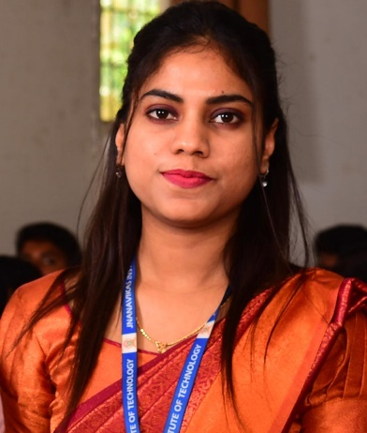
2 | Academic Information
 |  | Highest Qualification | MSc.,
 | b. | Specialization/ Area of Interest | Condensed Matter Physics
 | c. | Teaching Areas (Yrs/Months) / Courses Taught | Engineering Physics
 | d. | Research Interests | Yes
3 | Professional Details
 |  | Work Experience | 1 YEAR 11 MONTHS
 | b. | Current Responsibilities | HOD of Physics
 | c. | Membership in Professional Bodies | NIL
4 | Publications & Research
 |  | Research Publications | NIL
 | b. | Journals (with links or citations) | NIL
 | c. | Conferences | NIL
 | d. | Books / Book Chapters | NIL
 | e. | Google Scholar / Scopus / ORCID Links | NIL
 | f. | Projects Handled (Completed/Ongoing) | NIL
 | g. | Research Grants / Funding (details, amount, agency) | NIL
5 | Academic Contributions
 |  | Projects Guided (MBA/ BE in numbers) | NIL
 |  | PhD / M.Phil., / M.Sc. Supervision | NIL
 | b. | Curriculum Development/ Syllabus Design | NIL
 | c. | Workshops / Seminars / Conferences Attended or Organized | NIL
6 | Awards & Achievements
 |  | Academic Honors | NIL
 | b. | Awards / Fellowships | NIL
 | c. | Invited Talks / Guest Lectures | NIL
7 | Web & Media Links
 |  | Personal Academic Website / Blog | NIL
 | b. | LinkedIn / Research Gate | NIL
 | c. | YouTube / Media Appearances | NIL
8 | Downloads / Attachments
 |  | Curriculum Vitae (CV) PDF
 | b. | Research Papers / Teaching Portfolio | NIL

